Trend Analysis of Ambient Noise Level in Lucknow City
Dr. Lalji Verma^{1*}, Sh. Runa Oraon¹, Dr. Rajeev Kumar Singh¹
¹Central Pollution Control Board, Regional Directorate Lucknow
E-mail: lalji40@gmail.com^{1*}, runachem2k3gmail.com,
*correspondent author
Abstract
Noise generated by traffic and commercial activity like loudspeakers and DJs are the major sources of noise pollution. Lucknow city carries a million plus population engaged in industrial commercial as well as residential activity, the city has more than eleven major hospitals along with hundred plus miner hospitals as well as clinics, one major airport, dedicated four industrial areas, and one notified cantonment zone. The higher level of Noise is like parts of essential poisons. There are several activities causing noise pollution and its impact was observed on health and the environment. The study examines the concentrations of noise levels in different locations in Lucknow city. The datasets were collected continually the whole day through a continuous online monitoring system run and maintained by Uttar Pradesh Pollution Control Board and data was transmitted to the Central Pollution Control Board and average values were utilized to study the respective zone. The analysis is based on the empirical evidence and classification of various zone and their respective limits to regulate the strategic and future action plan to control noise levels.
Keywords: Government Policy, Health, Noise Pollution, Living hood activity, Noise Pollution Impact, Traffic.
Introduction
Noise may be classified as unwanted sound, undesirable and unpleasant sound, or sound that bothered or irritated and can lead to damage to the human ear or the human got irritated. The unwanted sound can cause several harmful effects to the Human, Vegetation, Animals, and Property. Some of the adverse effects of the high levels of noise may cause decreases in the performance efficiency of humans, Lack of concentration, Fatigue, may cause Abortion Causes, Temporary or Permanent Deafness, Effect on ecologically i.e. Vegetation- Poor quality of Crops, High Blood Pressure, and Effect on animals –can cause nervous system of animals. Lucknow district is located at 26° 30’- 27° 10’ North latitude and 80° 30’- 81° 13’ East longitude having a population 2817105 as per census 2011 (census 2011) about 8836 units registered (DC MSME) as on 2011 different type of processing and goods manufacturing unit as well as service provider area (notified as commercial area) for industry it include Eleven major Hospitals such as Dr. Shyama Prasad Mukharji Hospital (Civil), SGPGI, Lok Bandhu Hospital, RML Hospital, Balrampur Hospital, KGMU, Shahara Hospital, Medanta Hospital, Apollo Hospital, Command Hospital and Army Hospitals and more than hundred medium and small hospitals and clinic in its periphery. The Government of India (GoI) has notified the Ambient Noise standard to control noise pollution and betterment its citizen health. Singh, K. P. and Singha, S. (1983) defined noise as a type of atmospheric pollution in the form of waves. Ritovska et al., (2004) classification of noise polluter sources in various cities.
Table-1: Different sound levels and harmful effects
Noise level (dBA) | Possible psychological and physiological effects may cause due to Noise Pollution
65 | Annoyance, mental and physical fatigue.
90 | Very long exposure may cause permanent hearing loss.
100 | Short exposure may cause temporary damage; long exposure may cause permanent damage.
120 | Pain.
150 | Immediate loss of hearing.
Source: Ogunsote (1991)
The Noise Pollution (Control and Regulation) Rules, 2000 defined the National Ambient Noise Quality Standards and categorized several categories i.e., Industrial Areas, Commercial Areas, Residential Areas, and Silence Zone to monitor and control noise pollution in India.
Table-2
SCHEDULE
(See rule 3(1) and 4(1))
Ambient Air Quality Standards in Respect of Noise
Area Code | Category of Area / Zone | Limits in dB(A) L_{eq}*
Area Code | Category of Area / Zone | Daytime | Nighttime
(A) | Industrial area | 75 | 70
(B) | Commercial area | 65 | 55
(C) | Residential area | 55 | 45
(D) | Silence Zone | 50 | 40

Note: -
- Day Nighttime: 22.00 to 6.00
- A Silence zone is a demarcated area within 100 meters of hospitals, educational institutions, courts, religious places, or any other area that is notified by the competent authority.
- Mixed categories of areas may be notified as one of the four above-listed categories by the competent authority.
* dB(A) L_{eq} denotes the time-weighted average of the sound level in decibels on scale A which is relatable to human hearing.
A “decibel” is a unit in which Noise is measured.
“A”, in dB (A) L_{eq}, denotes the frequency weighting in the measurement of Noise and corresponds to frequency response characteristics of the human ear.
L_{eq}: It is the energy mean of the Noise level (Sound Intensity) over a specified period.
Classification of Industrial Area, Commercial Area, Residential Area, and Silence Zone of Lucknow city.
Table-3: Categorization of Lucknow city in several areas/zone
Sl. No. | Location of Monitoring stations | Category of area/zone
 | Talkatora | Industrial area
 | Hazratganj | Commercial area
 | S.G.P.G. I | Silence zone
 | Indira Nagar | Residential area
 | Gomti Nagar | Silence zone
 | Chinhat | Industrial area
 | IT College | Silence zone
 | Aliganj | Commercial area
 | Vibhuti Khand | Residential area
 | CCS Airport | Commercial area

Study area:
There is ten Real-Time National Ambient Noise Monitoring Networks (RTNANMn) have been installed in the Lucknow district in different areas/zone of the city covering Industrial, Silence, Residential, and Commercial areas. CPCB has installed ten (10) RTNANMn in Lucknow in different areas of the city covering Industrial (02 locations), Silence (03 locations), Residential (02 locations), and Commercial zone (03 locations). The data is transmitted to CPCB and UPPCB servers. Data is also made accessible to the public. Ambient Air Quality Standards in respect of Noise pollution have been notified based on area-specific viz. Industrial, Silence, Residential & Commercial area, and time specific viz. day and nighttime. Hence, trend analysis of noise level has been carried out concerning every location for day and nighttime. The data has been analyzed concerning each location in L_{eq} for day and night. The duration was taken from 2017 to 2020 (till May 2020).
Table-4: Effects on the population’s health of Sound levels at night
Average night noise intensity effects on Health observed in the population level over a year L _{night, outside} | Health effects observed in the population  (Note. The guidelines assume an average attenuation of 21 dB(A) between inside and outside noise levels.)
Up to 30 dB | Although individual sensitivities and circumstances may differ, it appears that up to these levels, no substantial biological effects are observed. L night, outside of 30 dB is equivalent to the no observed effect level (NOEL) for night noise.
30 to 40 dB | Several effects on sleep are observed from this range: body movements, awakening, self-reported sleep disturbance, and arousal. The intensity of the effect depends on the nature of the source and the number of events. Vulnerable groups (for example children, the chronically ill, and the elderly) are more susceptible. However, even in the worst cases, the effects seem modest. L night, outside of 40 dB is equivalent to the lowest observed adverse effect level (LOAEL) for night noise
40 to 55 dB | Adverse health effects are observed among the exposed population. Many people have to adapt their lives to cope with the noise at night. Vulnerable groups are more severely affected.
Above 55 dB | The situation is considered increasingly dangerous for public health. Adverse health effects occur frequently, and a sizeable proportion of the population is highly annoyed and sleep-disturbed. There is evidence that the risk of cardiovascular disease increases.
Source: Night noise guidelines for Europe (38).

- Location: Talkatora
The station in Talkatora is located Near District Industries Centre in Talkatora Industrial Area. The monitoring station is coming under the Industrial category. It has been observed that the noise level found always meets the stipulated norms for industrial areas during the day as well as at night during 2017, 2018, 2019, and 2020.
The minimum value from 2017 to 2019 was observed at 58.667 dB (daytime) in November 2018 and 23.792 dB (nighttime) in July 2019, which reached the maximum value of 75.024 dB (daytime) in December 2017 and 76.028 dB (nighttime) in July 2018. It indicates that the maximum value during nighttime is slightly higher than during daytime. Further, in 2020, the minimum value was observed 52.587 dB in January and 47.202 dB in April during the day and nighttime. Similarly, the maximum value was observed as 80.197 dB in February and 78.371 dB in January for day and nighttime respectively.
The trend of noise level for 2017, 2018, and 2019 indicated only a slight deviation. It can be seen in Figure 1.
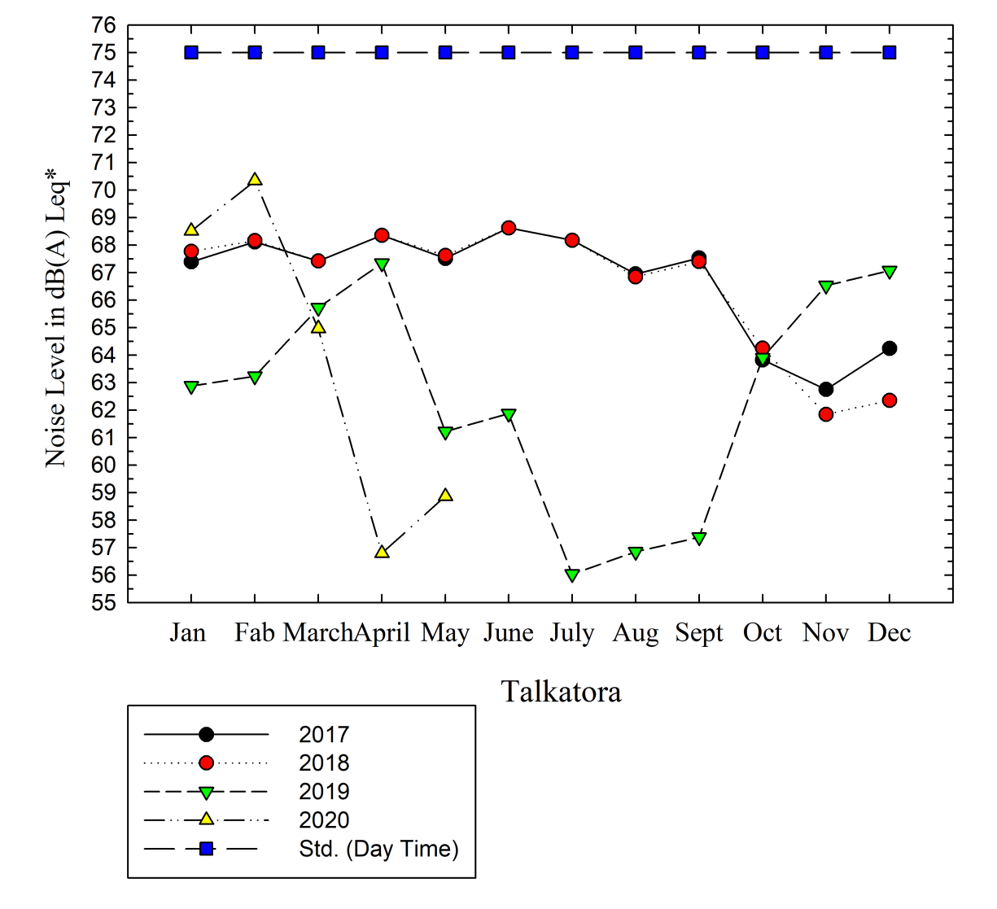 | 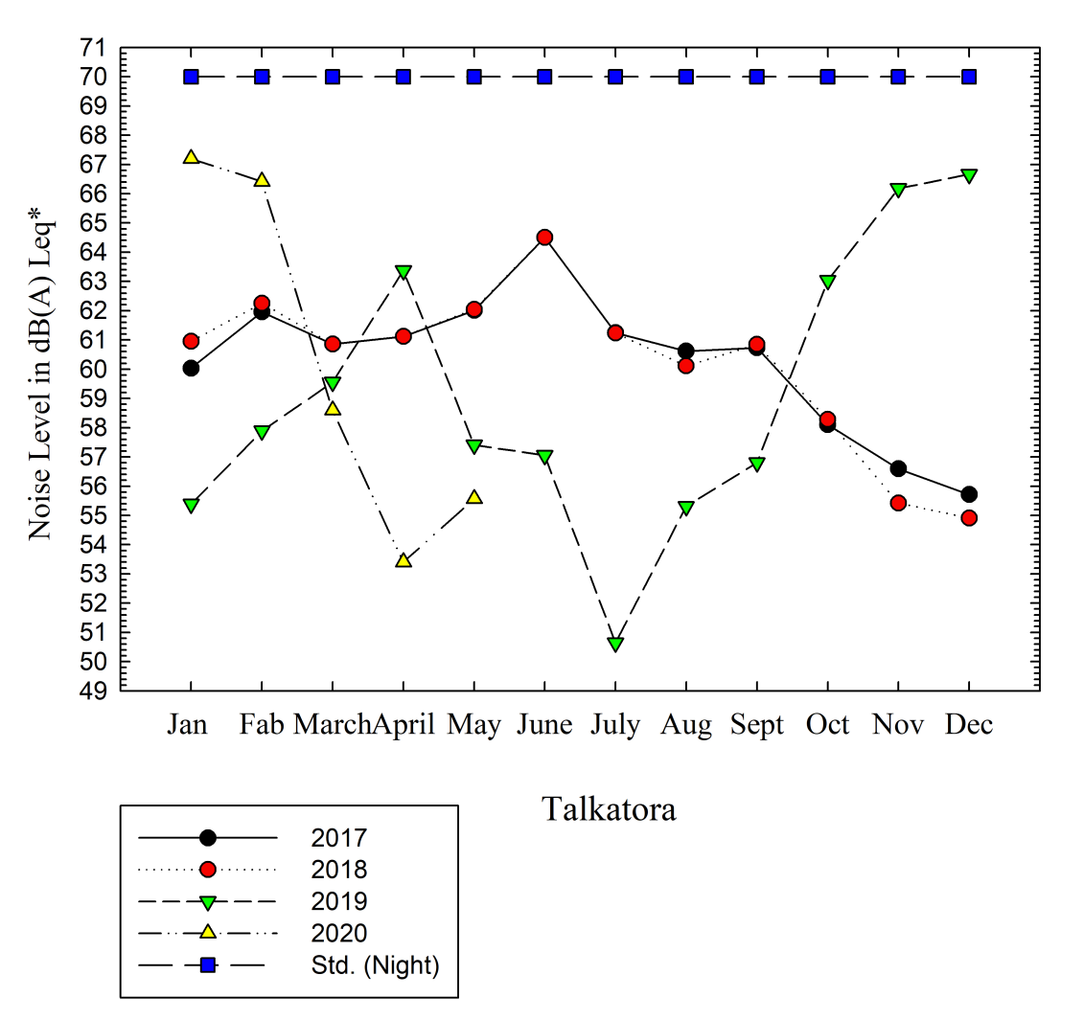
Figure-(1) Trend analysis of Talkatora Location Daytime | Figure-(2) Trend analysis of Talkatora Location Nighttime

- Location: Hazratganj
The station in Hazratganj is located at DRM Office. The monitoring station is coming under a commercial area. Hazratganj is also called as the center point of Lucknow and it is the main commercial hub of Lucknow City. It has been observed that the Noise level found mostly exceeded the notified Standards for commercial areas during the day as well as at night during 2017, 2018, and 2019 except for August, September, and October in 2018 and August, and September in 2017. A reducing trend observed in 2020 as the sound level reduces from January to April due to Lockdown and again it exceeds in May as Lockdown was relaxes in May.
The minimum value on a particular date from 2017 to 2019 was observed 28.067 dB (daytime) in July 2017 and 27.009 dB (nighttime) in August 2018, which reached the maximum value of 85.748 dB (daytime) in August 2019 and 83.468 dB (nighttime) in September 2019. Further, in 2020, the minimum value on a particular date was observed 52.77 dB in April month and 46.57 dB in March during the day and nighttime. Similarly, the maximum value was observed as 76.25 dB in May and 78.03 dB in January for day and nighttime respectively.
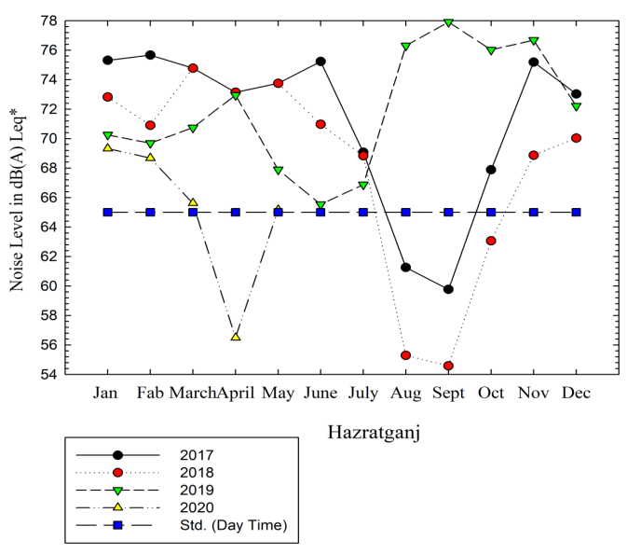 | 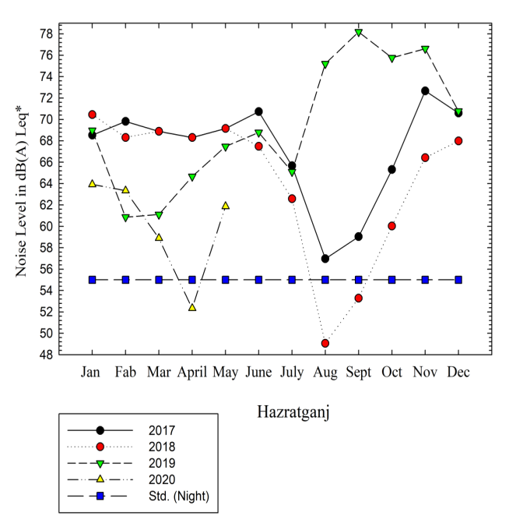
Figure-(3) Trend analysis of Hazaratganj location Daytime | Figure-(4) Trend analysis of Hazaratganj Location Nighttime

- Location: SGPGI
The station in SGPGI is located Near Railway Reservation Counter in SGPGI, Raebareilly Road. The monitoring station is coming under Silence Zone. It has been observed that the Noise level found always exceeded the notified Standards for the Silent zone during the day as well as at night during 2017, 2018, and 2019 except September 2019. It was also observed that the sound level exceeds very sharply in 2020. It may be due to the excessive movement of vehicles due to the pandemic COVID 19 and construction activity near the monitoring station.
The minimum value on a particular date from 2017 to 2019 was observed 15.91 dB (daytime) in September 2019 and 6.33 dB (nighttime) in September 2019, which reached the maximum value of 76.86 dB (daytime) in June 2018 and 77.475 dB (nighttime) in August 2019. It indicates that the minimum value during day and nighttime in consecutive three years (2017, 2018, and 2019) not meeting the notified Standards anytime. Further, in 2020, the minimum value on a particular date was observed 44.62 dB in January and 36.50 dB in March during the day and nighttime. Similarly, the maximum value on a particular date was observed as 92.87 dB in March and 98.06 dB in May for day and nighttime respectively.
The trend of Noise levels for 2017, 2018, and 2019 indicated only a slight deviation. It can be seen in the Table below:

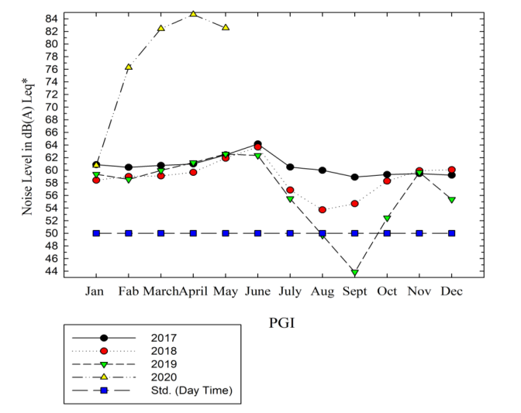 | 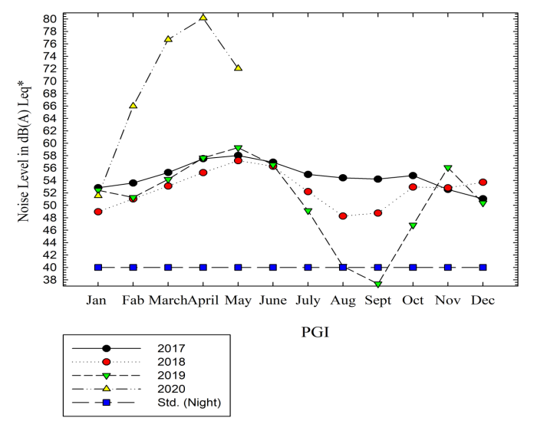
Figure-(5) Trend analysis of PGI Location Daytime | Figure-(6) Trend analysis of PGI Location Nighttime

- Location: Indira Nagar
The station in Indira Nagar is located at Sector-11, Near RLB Memorial School. The monitoring station is coming under Residential Area. It has been observed that the Noise level found always exceeded the notified Standards for Residential Areas during the day as well as at night during 2017, 2018, and 2020. But; it meets with the notified Standards since 2019. The higher values in 2020 may be due to the start of construction activity in nearby areas.
The minimum value on a particular date from 2017 to 2019 was observed 39.354 dB (daytime) in October 2019 and 30.012 dB (nighttime) in January 2019, which reached the maximum value of 63.547 dB (daytime) in February 2018 and 66.091 dB (nighttime) in November 2019. Further, in 2020 the minimum value was observed 40.04 dB in January and 37.86 dB in February during the day and nighttime. Similarly, the maximum value on a particular date was observed as 112.43 dB in March and 112.44 dB in March for day and nighttime respectively.
The trend of Noise levels for 2017, 2018, and 2019 indicated only a slight deviation. It can be seen in the Table below:
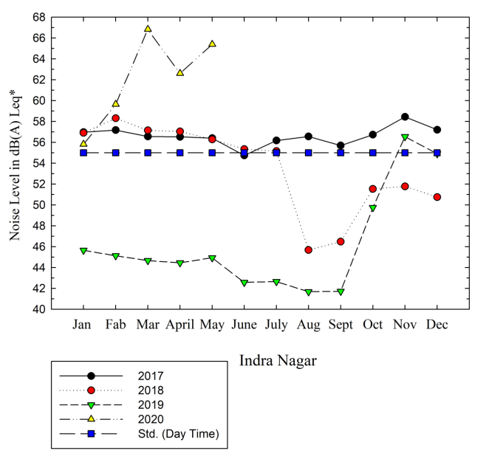 | 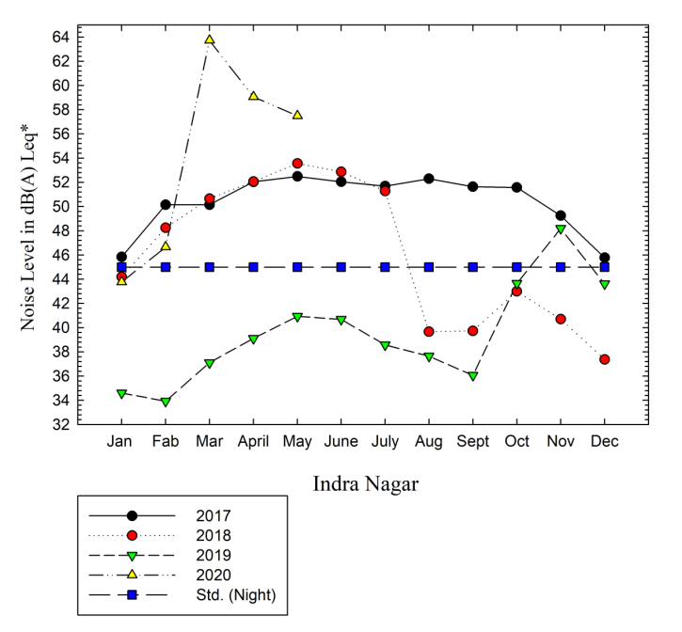
Figure-(7) Trend analysis of Indira Nagar location Daytime | Figure-(8) Trend analysis of Indira Nagar Location Nighttime

- Location: Gomti Nagar
The station in Gomti Nagar is located at RML Hospital, Vibhuti Khand, Gomti Nagar. The monitoring station is coming under the Silence zone/area. It has been observed that the concentration of Noise level found always exceeded the notified Standards for the Silence zone during the day as well as at night during 2017, 2018, 2019, and 2020.
The minimum value on a particular date from 2017 to 2019 was observed 61.293 dB (daytime) in October 2017 and 54.746 dB (nighttime) in January 2018, which reached the maximum value of 74.902 dB (daytime) in May 2018 and 82.561 dB (nighttime) in April 2018. It indicates that the minimum value during day and nighttime in consecutive three years (2017, 2018, and 2019) not meeting the notified Standards anytime. Further, in 2020, the minimum value was observed 55.20 dB in March and 50.40 dB in April during the day and nighttime. Similarly, the maximum value on a particular date was observed as 69.98 dB in May and 63.79 dB in February for day and nighttime respectively.
The trend of Noise levels for 2017, 2018, and 2019 indicates only a slight deviation. It can be seen in the Table below:
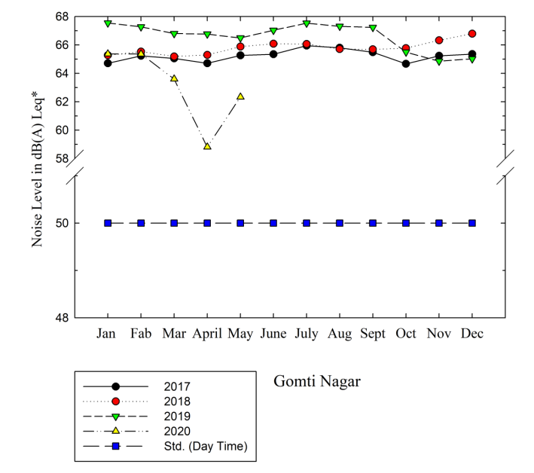 | 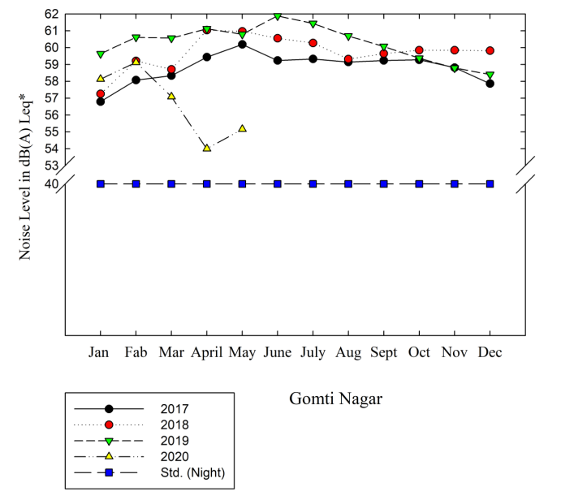
Figure-(9) Trend analysis of Gomti Nagar Location Daytime | Figure-(10) Trend analysis of Gomti Nagar Location Nighttime

- Location: Chinhat
The station in Chinhat is located in an Industrial Area. The monitoring station is coming under Industrial Area. It has been observed that the Noise level found always meets the notified Standards for Industrial Areas during the day as well as at night during 2017, 2018, 2019, and 2020.
The minimum value on a particular date from 2017 to 2019 was observed 50.253 dB (daytime) in March 2019 and 43.176 dB (nighttime) in November 2018, which reached the maximum value of 74.412 dB (daytime) in May 2017 and December 2018 and 66.613 dB (nighttime) in March 2019. Further, in 2020 the minimum value was observed 55.93 dB in March and 46.47 dB in January during the day and nighttime. Similarly, the maximum value on a particular date was observed as 76.55 dB and 69.92 dB in May for day and nighttime respectively.
The trend of average Noise levels in 2017, 2018, and 2019 indicated only a slight deviation. It can be seen in the Table below:
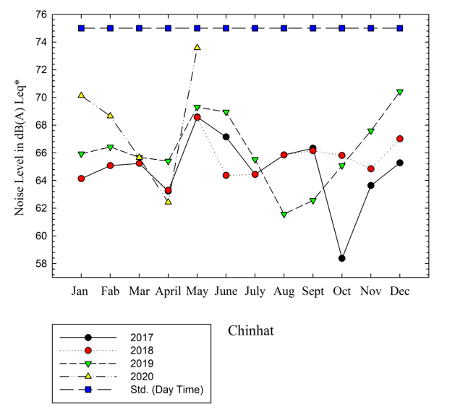 | 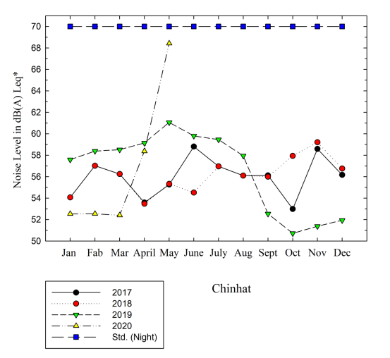
Figure-(11) Trend analysis of Chinhat Location Daytime | Figure-(12) Trend analysis of Chinhat Location Nighttime

- Location: IT College
The station in IT College is located at Nirala Nagar. The monitoring station is notified under the Silent zone/area. It has been observed that the concentration of Noise level found always exceeded the notified Standards for Silent Zone during the day as well as at night during 2017, 2018, 2019, and 2020.
The minimum value on a particular date from 2017 to 2019 was observed 55.816 dB (daytime) in December 2018 and 53.717 dB (nighttime) in November 2018, which reached the maximum value of 83.725 dB (daytime) in December 2019 and 91.402 dB (nighttime) in August 2017. It indicates that the minimum value during day and nighttime in consecutive three years (2017, 2018, and 2019) not meeting the notified Standards anytime. Further, in 2020, the minimum value was observed 52.87 dB and 51.37 dB in March during the day and nighttime. Similarly, the maximum value on a particular date was observed as 69.04 dB in January and 62.97 dB in March for day and nighttime respectively.
The trend of average Noise levels for 2017, 2018, and 2019 indicated only a slight deviation. It can be seen in the Table below:
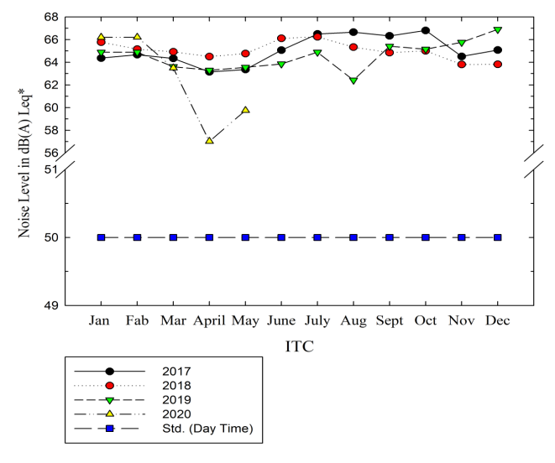 | 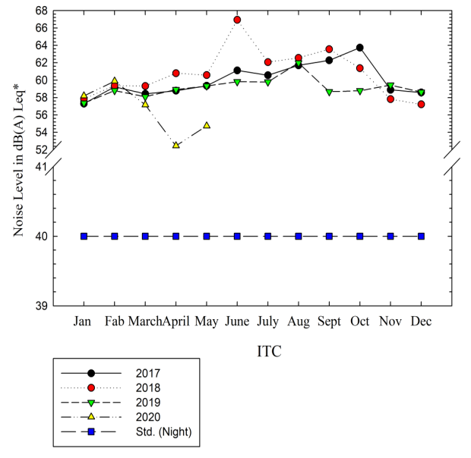
Figure-(13) Trend analysis of IT Collage Location Daytime | Figure-(14) Trend analysis of IT Collage Location Nighttime

- Location: Aliganj
The station in Aliganj is located at Sector-J, Aliganj. The monitoring station is coming under the commercial category. It has been observed that the Noise level found always exceeded the notified Standards for commercial zone/categories during the day as well as at night during 2017, 2018, and 2019. But; it meets with the notified Standards since March 2020.
The minimum value on a particular date from 2017 to 2019 was observed 71.405 dB (daytime) in May 2019 and 61.919 dB (nighttime) in August 2019, which reached the maximum value of 80.998 dB (daytime) in March 2018 and 83.98 dB (nighttime) in June 2018. It indicates that the minimum value during day and nighttime in consecutive three years (2017, 2018, and 2019) not meeting the notified Standards anytime. Further, in 2020, the minimum value was observed 50.638 dB and 48.404 dB during the day and nighttime in May respectively. Similarly, the maximum value on a particular date was observed as 67.234 dB in January and 64.093 dB in February for day and nighttime respectively.
The trend of average Noise levels for 2017, 2018, and 2019 indicated only a slight deviation. It can be seen in the Table below:
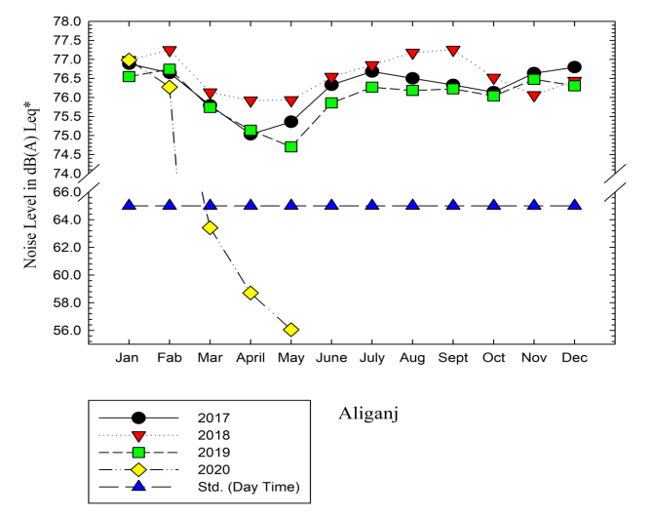 | 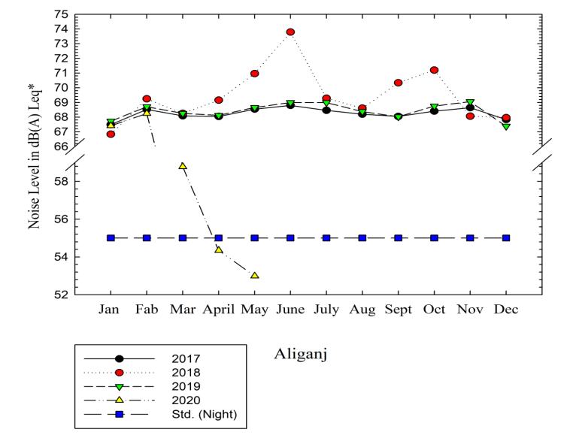
Figure-(15) Trend analysis of Aliganj Location Daytime | Figure-(16) Trend analysis of Aliganj Location Nighttime

- Location: Vibhuti Khand, Gomtinagar
The station in Vibhuti Khand is located at Uttar Pradesh Pollution Control Board, Head Office, Building No. TC-12 V, Vibhuti Khand, Gomti Nagar. The monitoring station is coming under Residential Area. It has been observed that the Noise level found always exceeded the notified Standards for Residential Areas during the day as well as at night during 2017, 2018, 2019, and 2020 (Till May 2020).
The minimum value on a particular date from 2017 to 2019 was observed 58.888 dB (daytime) in August 2018 and 51.579 dB (nighttime) in December 2019, which reached the maximum value of 89.644 dB (daytime) and 93.457 dB (nighttime) in December 2019 respectively. It indicates that the minimum value during day and nighttime in consecutive three years (2017, 2018, and 2019) not meeting the notified Standards anytime. Further, in 2020, the minimum value was observed 54.134 dB and 50.238 dB during the day and nighttime in April month. Similarly, the maximum value on a particular date was observed as 71.616 dB in March and 66.644 dB in May for day and nighttime respectively.
The trend of average Noise levels for 2017, 2018, and 2019 indicated only a slight deviation. It can be seen in the Table below:
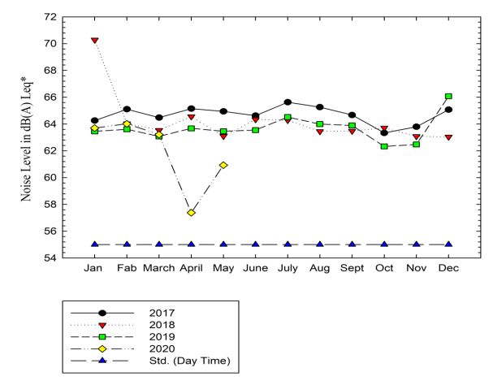 | 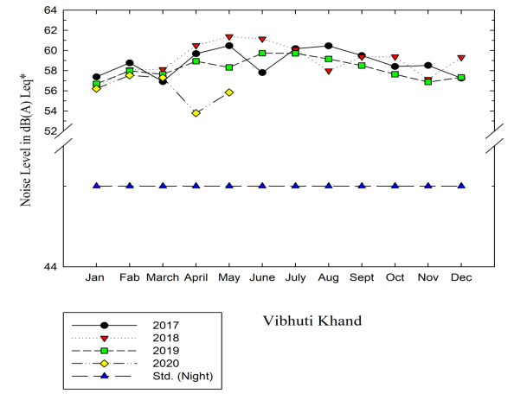
Figure-(17) Trend analysis of Vibhuti Khand Gomti Nagar Location Daytime | Figure-(18) Trend analysis of Vibhuti Khand Gomti Nagar location Nighttime

- Location: Chaudhary Charan Singh (CCS) Airport
The station in CCS Airport is located at Amausi. The monitoring station is coming under Commercial Area. It has been observed that the Noise level found always meeting the notified Standards for Commercial Areas in the daytime, but not meeting the norms at night during 2017, 2018, and 2019. In 2020, Noise level meeting the notified Standards after March onwards.
The minimum value on a particular date from 2017 to 2019 was observed 55.521 dB (daytime) in January 2018 and 50.893dB (nighttime) in January 2017, which reached the maximum value of 85.390 dB (daytime) and 94.075 dB (nighttime) in December 2019 respectively. Further, in 2020, the minimum value was observed 52.975 dB and 47.439 dB during the day and nighttime in April month respectively. Similarly, the maximum value on a particular date was observed as 69.968 dB and 63.538 dB for day and nighttime in February month respectively.
The trend of average Noise levels for 2017, 2018, and 2019 indicated only a slight deviation. It can be seen in the Table below:
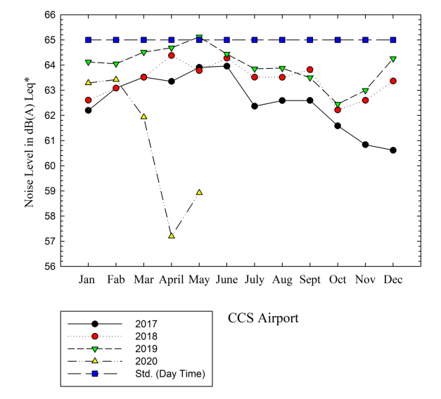 | 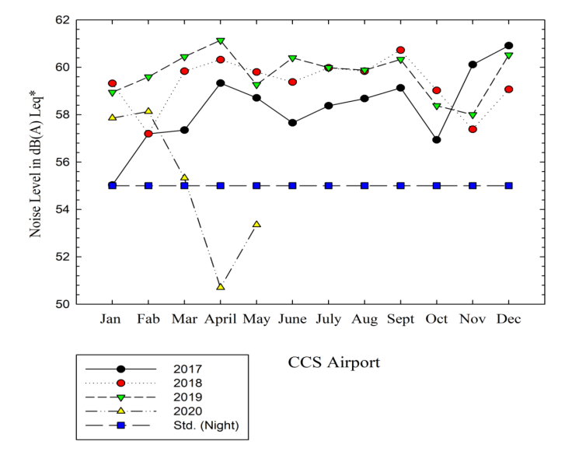
Figure-(19) Trend analysis of Chaudhary Charan Singh (CCS) Airport Location Daytime | Figure-(20) Trend analysis of Chaudhary Charan Singh (CCS) Airport Location Nighttime

Conclusion: -
For trend analysis undertaken in the period 2017-19, it is noted that except for Indira Nagar, there has been no appreciable change. In the case of Indira Nagar, the probable reason might be restricted traffic on account of construction / restricted movement during Lucknow Metro construction activities. The status of % variation in Noise level from 2017 to 2019 is as below:
S. No. | Location | Area Category | % Reduction/ Deviation (+Reduction and – increasing)
1 | Talkatora | Industrial Area | 6.29 (Daytime)
1 | Talkatora | Industrial Area | 2.03 (Nighttime)
2 | Hazratganj | Commercial | 1.08(Daytime)
2 | Hazratganj | Commercial | 3.51(Nighttime)
3 | S.G.P.G. I | Silence | 6.44(Daytime)
3 | S.G.P.G. I | Silence | 6.88(Nighttime)
4 | Indira Nagar | Residential | 18.32(Daytime)
4 | Indira Nagar | Residential | 21.54(Nighttime)
5 | Gomti Nagar | Silence | 2.10(Daytime)
5 | Gomti Nagar | Silence | 2.48(Nighttime)
6 | Chinhat | Industrial | 2.57(Daytime)
6 | Chinhat | Industrial | 1.44(Nighttime)
7 | IT College | Silence | 0.83 (Daytime)
7 | IT College | Silence | 1.43 (Nighttime)
8 | Aliganj | Commercial | 0.32 (Daytime)
8 | Aliganj | Commercial | 0.24 (Nighttime)
9 | Vibhuti Khand | Residential | 1.56 (Daytime)
9 | Vibhuti Khand | Residential | 0.95 (Nighttime)
10 | CCS Airport | Commercial | 2.31(Daytime)
10 | CCS Airport | Commercial | 2.48(Nighttime)

- Trend analysis of the Noise level of Lucknow City from 2017 to 2019 based on the Real Time Noise Monitoring Stations at 10 locations indicates mostly slight reduction or increase (reduction to 6.88 and increase up to 2.57 %) in the Noise level except Indira Nagar (Residential Zone), where reduction is observed 18.32%(day) and 21.54%(night).
- The increase or decrease trend in the Noise level is not significant and change is observed only for up to 02 dB from 2017 to 2019 except in Indira Nagar where the decreasing trend is observed up to 10 dB.
- An increasing trend was observed especially in the Commercial zone. While most of the place decreasing trend was observed.
- The Noise level in Residential, Commercial, as well as the silent zone, is mostly found to exceed the notified Standards.
- In the case of Industrial Areas, the Noise level is always found to conform to notified standards in Day as well in Nighttime.

References

  - Charlotte Hurtley, Layout by Dagmar Bengs (2009) “NIGHT NOISE GUIDELINES FOR EUROPE”.
  - Census2011.co.in
  - Dcmsme.gov.in
  - Directive 2002/49/EC of the European Parliament and of the Council of 25 June 2002 relating to the assessment and management of environmental noise. (2002) Official Journal of the European Communities, L 189, 12–25.
  - Ogunsote, O. O. (1991). Introduction to Building Climatology – A Basic Course for Architecture Students. Zaria: Ahmadu Bello University Press Limited.
  - Ritovska, G., Djorgjev, D., & Jordanova, N. (2004). Psychosocial Effects of Community Noise: Cross-Sectional Study of School Children in Urban Center of Skopje, Macdonia. Croatian Medical Journal, 45(4), 473-476.
  - Singh, K.P and Singha, S (1983). Noise Pollution Impact and Control in Environmental Management.
  - The Principal Rules were published in the Gazette of India, vide S.O. 123(E), dated 14.2.2000 and subsequently amended vide S.O. 1046(E), dated 22.11.2000, S.O. 1088(E), dated 11.10.2002, S.O. 1569 (E), dated 19.09.2006 and S.O. 50 (E) dated 11.01.2010 under the Environment (Protection) Act, 1986.)

